Using Microsoft Whiteboard with Teams

Posted on [**May 21, 2020**](https://office365itpros.com/2020/05/21/using-microsoft-whiteboard-teams/) by [**Tony Redmond**](https://office365itpros.com/author/thoughtsofanidlemind/)

Collaborating on a Digital Canvas

Whiteboard is an application intended to allow people to collaborate by drawing and refining ideas on a digital canvas (board), or as Microsoft says an “*infinite canvas where imagination has room to grow*.” Whiteboard runs as an Azure service and is enabled by default for all Office 365 enterprise tenants. If you want, you can disable Whiteboard through tenant settings in the Microsoft 365 admin center.

Users can access Whiteboard through the Office menu, which launches the [**browser version**](https://whiteboard.microsoft.com/), signing in with their Azure AD credentials to create, update, or remove whiteboards. Versions are also available in the Microsoft Store and [**for iOS**](https://apps.apple.com/us/app/microsoft-whiteboard/id1352499399) A standalone version isn’t available for Android, but the Teams app version can be used through the [**Teams client for Android**](https://mspoweruser.com/microsoft-teams-for-android-updated-with-whiteboard-integration-and-more/).

Using Whiteboard in a Teams Meeting

Whiteboard is available in the share tray for Teams meetings. When used in a meeting, you can open Whiteboard in Teams or use the app (if installed on a Windows PC). Opening Whiteboard in Teams [**calls the app, which is based on the browser version**](https://techcommunity.microsoft.com/t5/office-365-blog/microsoft-whiteboard-now-available-for-the-web-and-integrated-in/ba-p/973566). The Whiteboard app in Teams is enough to share ideas (Figure 1) without getting too complex. If your PC supports digital inking, you can draw with your finger or a digital pen in a board, which works surprisingly well.

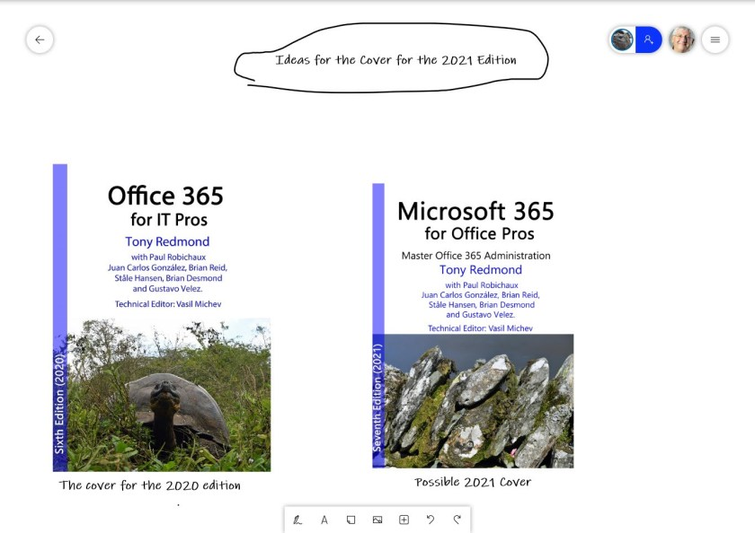Figure 1: The Whiteboard app in Teams

When you create a board for a meeting, it is associated with the meeting and all meeting participants can access the board during the meeting and afterwards. Because a board is a common resource that everyone connects to, changes made to the board are seen everywhere in real time. All whiteboards created in Teams meeting get the same “Whiteboard meeting” name. To avoid confusion, you can select a board in the list of boards in the app and edit it to assign a more meaningful name.

Teams isn’t limited to Whiteboard when it comes to discussing ideas on a digital canvas as [**other brainstorming applications**](https://techcommunity.microsoft.com/t5/microsoft-teams-blog/whiteboarding-and-brainstorming-in-microsoft-teams/ba-p/1353554?OCID=usoc_TWITTERMicrosoftTeams_M365_spl100001260172183) are in the Teams app store.

Whiteboard content is stored in its own Azure service. It is not captured by Teams compliance records, nor is the content indexed and available to content searches and eDiscovery cases.

Whiteboard for Windows

The Windows version is the most functional client (some good tips for using Whiteboard in the Windows client can be found in [**here**](https://www.guidingtech.com/top-microsoft-whiteboard-tips-tricks/) and [**here**](https://office-watch.com/2018/microsoft-whiteboard-depth/)). Additional formatting tools are available along with sticky notes and templates designed to get ideas flowing. Figure 2 shows the brainstorming template being used to refine ideas for an online seminar. Sometimes the browser version doesn’t do a great job of displaying boards containing complex formatting (like the templates), which is a good reason to use the Windows version anytime you want to work on something complicated.

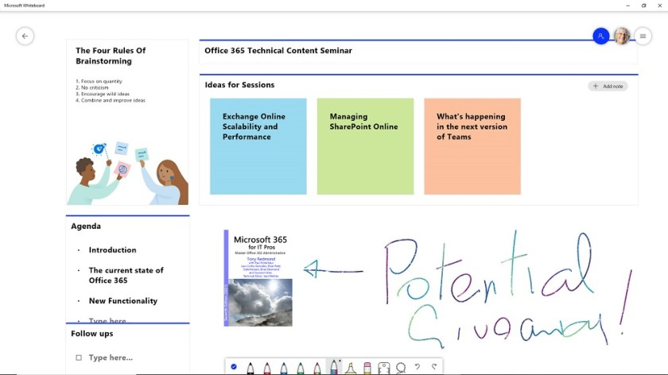Figure 2: Working in the Windows Whiteboard app

Sharing Whiteboards

Often a discussion centered will reach a conclusion that you want to share with other people who weren’t in the discussion. A Post to Teams option is available in the Windows app to post a link to the board as a message in a selected channel (Figure 3).

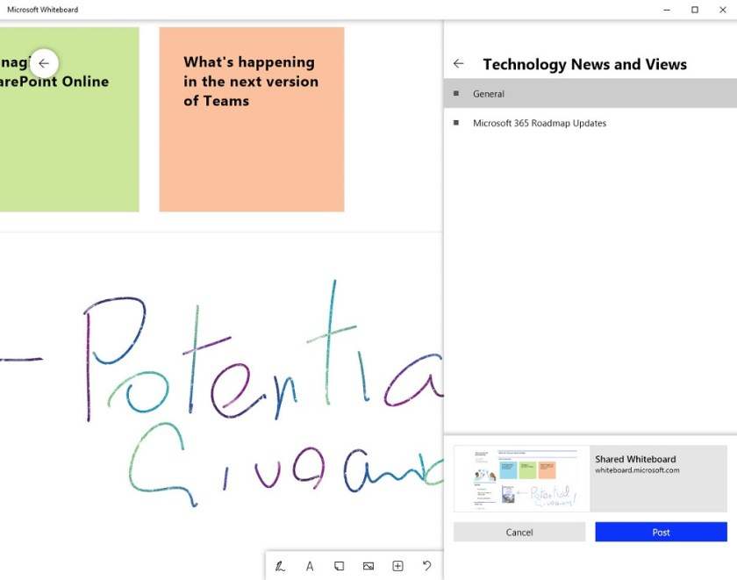Figure 3: Post to Teams from Whiteboard

The link can be copied from Teams and used to share the board with other people via email or in a personal chat. It looks something like this:

[***https://wbd.ms/share/v2/aHR0cHM6Ly93aGl0ZWJvYXJkLm1pY3Jvc29mdC5jb20vYXBpL3YxLjcvd2hpdGVib2FyZHMvcmVkZWVtL2Q0MjhlNzlmMmY5YTQyZWI4NzFmZjJlNDY0YzhhZjQ1X2I2NjIzMTNmLTE0ZmMtNDNhMi05YTdhLWQyZTI3ZjRmMzQ3OA==***](https://wbd.ms/share/v2/aHR0cHM6Ly93aGl0ZWJvYXJkLm1pY3Jvc29mdC5jb20vYXBpL3YxLjcvd2hpdGVib2FyZHMvcmVkZWVtL2Q0MjhlNzlmMmY5YTQyZWI4NzFmZjJlNDY0YzhhZjQ1X2I2NjIzMTNmLTE0ZmMtNDNhMi05YTdhLWQyZTI3ZjRmMzQ3OA==)

Clicking the link opens the board in the app (if installed) or the browser. You can only share boards with other tenant users.

If you don’t want to send a link, you can save a static view of a whiteboard as a graphic file (SVG or PNG format) and include the file in email, document, or web page.

Sharing Links

It’s also possible to invite other users to collaborate in Whiteboard through sharing invitations sent via email. The link can be read-only or allow full write access. When the recipient accepts the invitation, whiteboard adds the board to their list of available boards and opens the board to allow them to can contribute immediately. Invited users aren’t allowed to delete boards.

New Features Coming

In late 2019, Microsoft said that they plan to bring more features to the web app and Teams over time, including multiple pen types and the ability to format text. In April, they said that new functionality would be coming to the web app “*later this year*.” Guests can interact with boards during Teams meetings, but full guest access to Whiteboard is due to be delivered later in 2020.

PowerShell Support for Whiteboard

A PowerShell module is available for Whiteboard. The module is limited (just three cmdlets) and it is hard to know exactly how these cmdlets would be used in day-to-day administration, apart from using the [**Invoke-TransferAllWhiteboards**](https://docs.microsoft.com/en-us/powershell/module/whiteboard/invoke-transferallwhiteboards?view=whiteboard-ps) cmdlet to transfer ownership of boards from one user to another when someone leaves the organization. This point needs to be added to the checklist for user account removal in case an important whiteboard is deleted along with its owner’s account.